DAY_9

TASK_1

**package** DAY_9;

**import** org.testng.annotations.Test;

**import** org.testng.annotations.DataProvider;

**publicclass** task_1 {

**int**c;

@Test(dataProvider = "dp")

**publicvoid** Add(Integer n, Integer m) {

c=n+m;

System.***out***.println("sum="+c);

}

@Test(dataProvider = "dp")

**publicvoid** Sub(Integer n, Integer m) {

c=n-m;

System.***out***.println("difference="+c);

}

@Test(dataProvider = "dp")

**publicvoid** Mul(Integer n, Integer m) {

c=n*m;

System.***out***.println("product="+c);

}

@Test(dataProvider = "dp")

**publicvoid** Div(Integer n, Integer m) {

c=n/m;

System.***out***.println("quotient="+c);

}

@DataProvider

**public** Object[][] dp() {

**returnnew** Object[][] {

**new** Object[] { 1, 4 },

**new** Object[] { 2, 7 },

};

}

}

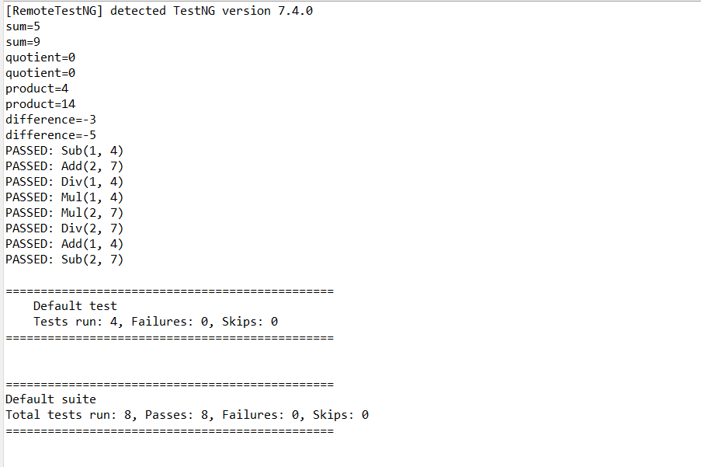

TASK_2 AND 3

JAVA.FILE

**package** DAY_9;

**import** java.util.concurrent.TimeUnit;

**import** org.openqa.selenium.By;

**import** org.openqa.selenium.WebDriver;

**import** org.openqa.selenium.chrome.ChromeDriver;

**import** org.openqa.selenium.chrome.ChromeOptions;

**import** org.testng.Assert;

**import** org.testng.annotations.Test;

**import** io.github.bonigarcia.wdm.WebDriverManager;

**publicclass** task_2 {

@Test

**publicvoid** Test1() {

WebDriverManager.*chromedriver*().setup();

WebDriver driver;

ChromeOptions co = **new** ChromeOptions();

co.addArguments("--remote-allow-origins=*");

driver=**new** ChromeDriver(co);

driver.get("https://www.godaddy.com/en-in");

driver.manage().window().maximize();

String actualTitle="Domain Names, Websites, Hosting & Online Marketing Tools - GoDaddy IN";

String extractedTitle=driver.getTitle();

Assert.*assertEquals*(actualTitle, extractedTitle);

String actualURL="https://www.godaddy.com/en-in";

String extractedURL=driver.getCurrentUrl();

Assert.*assertEquals*(actualURL, extractedURL);

driver.manage().timeouts().~~implicitlyWait~~(0, TimeUnit.***MILLISECONDS***);

driver.quit();

}

@Test

**publicvoid** Test2() {

WebDriverManager.*chromedriver*().setup();

WebDriver driver;

ChromeOptions co = **new** ChromeOptions();

co.addArguments("--remote-allow-origins=*");

driver=**new** ChromeDriver(co);

driver.get("https://www.godaddy.com/en-in");

driver.manage().window().maximize();

driver.manage().timeouts().~~implicitlyWait~~(3000, TimeUnit.***SECONDS***);

driver.findElement(By.*xpath*("//*[@id=\"id-631b049a-e9c0-4d24-8710-c504745206dd\"]/div[2]/div[1]/ul/li[1]/button")).click();

driver.findElement(By.*linkText*("Domain Name Search")).click();

driver.quit();

}

@Test

**publicvoid** Test3() {

WebDriverManager.*chromedriver*().setup();

WebDriver driver;

ChromeOptions co = **new** ChromeOptions();

co.addArguments("--remote-allow-origins=*");

driver=**new** ChromeDriver(co);

driver.get("https://www.godaddy.com/en-in");

driver.manage().window().maximize();

driver.manage().timeouts().~~implicitlyWait~~(3000, TimeUnit.***SECONDS***);

driver.findElement(By.*xpath*("//*[@id=\"id-631b049a-e9c0-4d24-8710-c504745206dd\"]/div[2]/div[1]/ul/li[1]/button")).click();

driver.findElement(By.*linkText*("Domain Name Search")).click();

String titl=driver.getTitle();

System.***out***.println("Title="+titl);

driver.quit();

}

}

XML FILE

<?xml version="1.0" encoding="UTF-8"?>

<!DOCTYPE suite SYSTEM "https://testng.org/testng-1.0.dtd">

<suite name="Suite">

<test thread-count="5" name="Test" parallel="methods">

<classes>

<class name="DAY_9.task_2"/>

</classes>

</test><!-- Test -->

</suite><!-- Suite -->

**output**

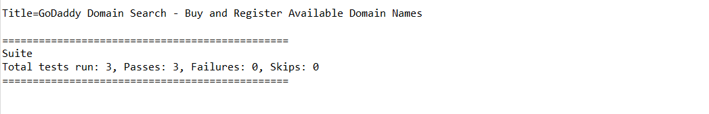

TASK_4

**package** DAY_9;

**importstatic** org.testng.Assert.*assertEquals*;

**import** org.openqa.selenium.By;

**import** org.openqa.selenium.WebDriver;

**import** org.openqa.selenium.chrome.ChromeDriver;

**import** org.openqa.selenium.chrome.ChromeOptions;

**import** org.testng.annotations.BeforeSuite;

**import** org.testng.annotations.Test;

**import** io.github.bonigarcia.wdm.WebDriverManager;

**publicclass** task_4 {

WebDriver driver;

@BeforeSuite

**void**init() {

WebDriverManager.*chromedriver*().setup();

ChromeOptions co = **new** ChromeOptions();

co.addArguments("--remote-allow-origins=*");

driver = **new** ChromeDriver(co);

}

@Test

**void** Test1() **throws** InterruptedException {

driver.get("https://opensource-demo.orangehrmlive.com/web/index.php/auth/login");

Thread.*sleep*(2000);

driver.findElement(By.*xpath*("//*[@name=\"username\"]")).sendKeys("Admin");

driver.findElement(By.*xpath*("//*[@name=\"password\"]")).sendKeys("admin123");

driver.findElement(By.*xpath*("//*[@id=\"app\"]/div[1]/div/div[1]/div/div[2]/div[2]/form/div[3]/button")).click();

*assertEquals*(driver.getCurrentUrl(), "https://opensource-demo.orangehrmlive.com/web/index.php/dashboard/index");

}

@Test(dependsOnMethods = "Test1")

**void** Test2() **throws** InterruptedException {

Thread.*sleep*(2000);

driver.findElement(By.*xpath*("//*[@id=\"app\"]/div[1]/div[1]/header/div[1]/div[2]/ul/li/span/p")).click();

driver.findElement(By.*xpath*("//*[@id=\"app\"]/div[1]/div[1]/header/div[1]/div[2]/ul/li/ul/li[4]/a")).click();

*assertEquals*(driver.getCurrentUrl(), "https://opensource-demo.orangehrmlive.com/web/index.php/auth/login");

}

}

output

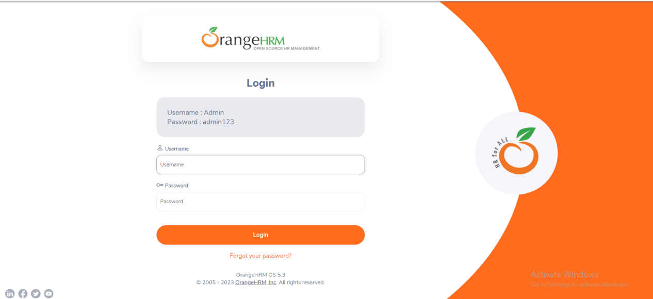

TASK_5

**package** DAY_9;

**import** org.testng.annotations.Test;

**import** io.github.bonigarcia.wdm.WebDriverManager;

**import**org.testng.annotations.BeforeMethod;

**importstatic** org.testng.Assert.*assertEquals*;

**import** org.openqa.selenium.By;

**import** org.openqa.selenium.WebDriver;

**import** org.openqa.selenium.chrome.ChromeDriver;

**import** org.openqa.selenium.chrome.ChromeOptions;

**import** org.testng.annotations.AfterMethod;

**publicclass** task_5 {

WebDriver driver;

@Test

**publicvoid** function() **throws** InterruptedException {

driver.findElement(By.*xpath*("//*[@name=\"username\"]")).sendKeys("Admin");

driver.findElement(By.*xpath*("//*[@name=\"password\"]")).sendKeys("admin123");

driver.findElement(By.*xpath*("//*[@class=\"oxd-button oxd-button--medium oxd-button--main orangehrm-login-button\"]")).click();

*assertEquals*(driver.getCurrentUrl(), "https://opensource-demo.orangehrmlive.com/web/index.php/dashboard/index");

}

@BeforeMethod

**publicvoid** beforeMethod() **throws** InterruptedException {

WebDriverManager.*chromedriver*().setup();

ChromeOptions co = **new** ChromeOptions();

co.addArguments("--remote-allow-origins=*");

driver = **new** ChromeDriver(co);

driver.get("https://opensource-demo.orangehrmlive.com/web/index.php/auth/login");

Thread.*sleep*(2000);

driver.manage().window().maximize();

}

@AfterMethod

**publicvoid** afterMethod() {

driver.close();

}

}

**Listener**

**package** DAY_9;

**import** org.testng.ITestContext;

**import** org.testng.ITestListener;

**import** org.testng.ITestResult;

**publicclass** listenerTask5 **implements** ITestListener{

**publicvoid** onTestStart(ITestResult result) {

// **TODO** Auto-generated method stub

System.***out***.println("onTestStart : "+result.getName());

}

**publicvoid**onTestSuccess(ITestResult result) {

// **TODO** Auto-generated method stub

System.***out***.println("onTestSuccess : "+result.getName());

}

**publicvoid** onTestFailure(ITestResult result) {

// **TODO** Auto-generated method stub

System.***out***.println("onTestFailure : "+result.getName());

}

**publicvoid** onTestSkipped(ITestResult result) {

// **TODO** Auto-generated method stub

System.***out***.println("onTestSkipped : "+result.getName());

}

**publicvoid** onTestFailedButWithinSuccessPercentage(ITestResult result) {

// **TODO** Auto-generated method stub

System.***out***.println("onTestFailedButWithinSuccessPercentage : "+result.getName());

}

**publicvoid** onTestFailedWithTimeout(ITestResult result) {

// **TODO** Auto-generated method stub

System.***out***.println("onTestFailedWithTimeout"+result.getName());

}

**publicvoid** onStart(ITestContext context) {

// **TODO** Auto-generated method stub

System.***out***.println("OnStart : "+context);

}

**publicvoid** onFinish(ITestContext context) {

// **TODO** Auto-generated method stub

System.***out***.println("OnFinish : "+context);

}

}

**Xml**

<?xml version="1.0" encoding="UTF-8"?>

<!DOCTYPE suite SYSTEM "https://testng.org/testng-1.0.dtd">

<suite name="Suite">

<test thread-count="5" name="Test">

<listeners><listener class-name="DAY_9.listenerTask5"></listener></listeners>

<classes>

<class name="DAY_9.task_5"/>

</classes>

</test><!-- Test -->

</suite><!-- Suite -->

**Output**

